Quiz 2

Question 1:

Implement the following topology and use BGP protocol.

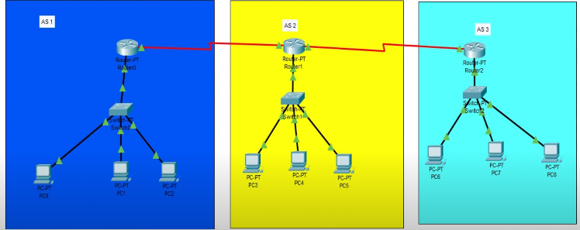

Submission should include the following:

Network figure screenshot

Screenshots of BGP Configurations on all three routers

Screenshot of pinging from one PC to another (in the same network and in the different network)

.pkt file (if it is downloadable)

